Test Case: tc001_SPX_Dev5_Crear_Nueva_Linea_Requisicion_Spot_Tipo_Cobro_CC
Step 1 - Enter username and password and click to button Enter : Credentials Entered
Image file-name: QC_Testing-tc001_SPX_Dev5_Crear_Nueva_Linea_Requisicion_Spot_Tipo_Cobro_CC-nov. 28 2025, 09 31 50 a. m.

Image file-name: QC_Testing-tc001_SPX_Dev5_Crear_Nueva_Linea_Requisicion_Spot_Tipo_Cobro_CC-nov. 28 2025, 09 31 51 a. m.

Step 2 - Select to UEN and Access to Spot Buy Requisitions : UEN Correctly selected and Correct access
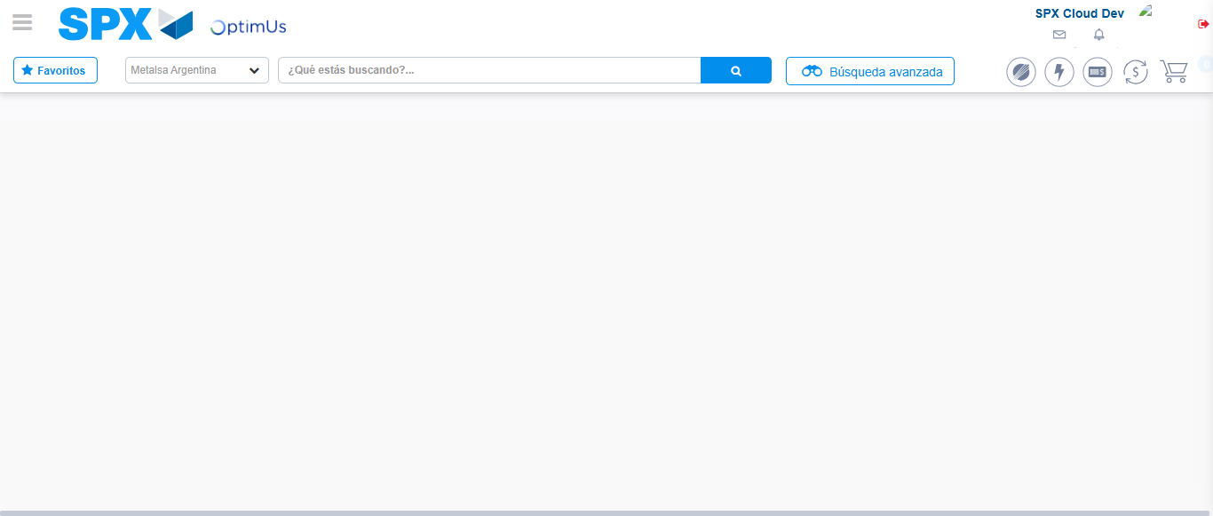Image file-name: QC_Testing-tc001_SPX_Dev5_Crear_Nueva_Linea_Requisicion_Spot_Tipo_Cobro_CC-nov. 28 2025, 09 31 54 a. m.

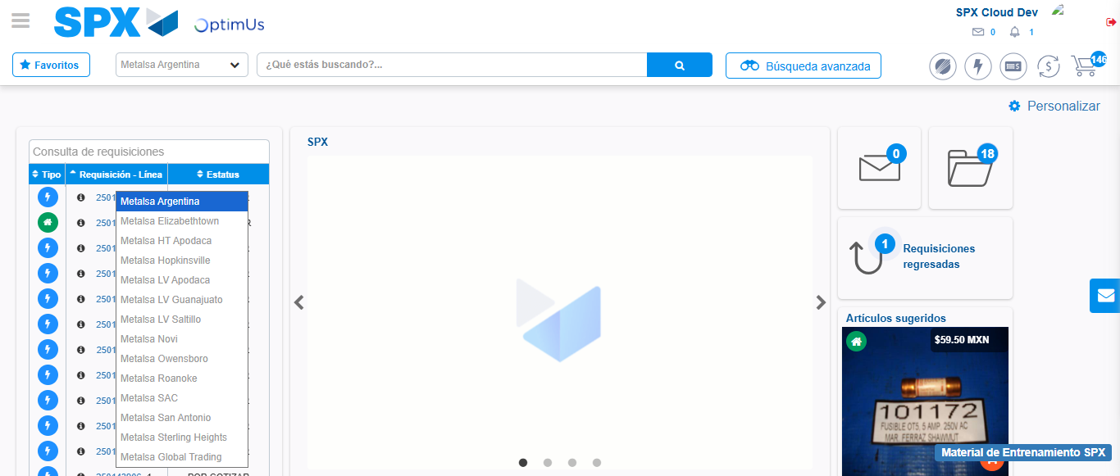Image file-name: QC_Testing-tc001_SPX_Dev5_Crear_Nueva_Linea_Requisicion_Spot_Tipo_Cobro_CC-nov. 28 2025, 09 31 55 a. m.

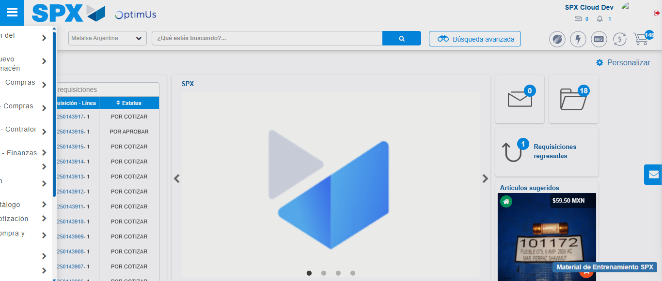Image file-name: QC_Testing-tc001_SPX_Dev5_Crear_Nueva_Linea_Requisicion_Spot_Tipo_Cobro_CC-nov. 28 2025, 09 31 56 a. m.

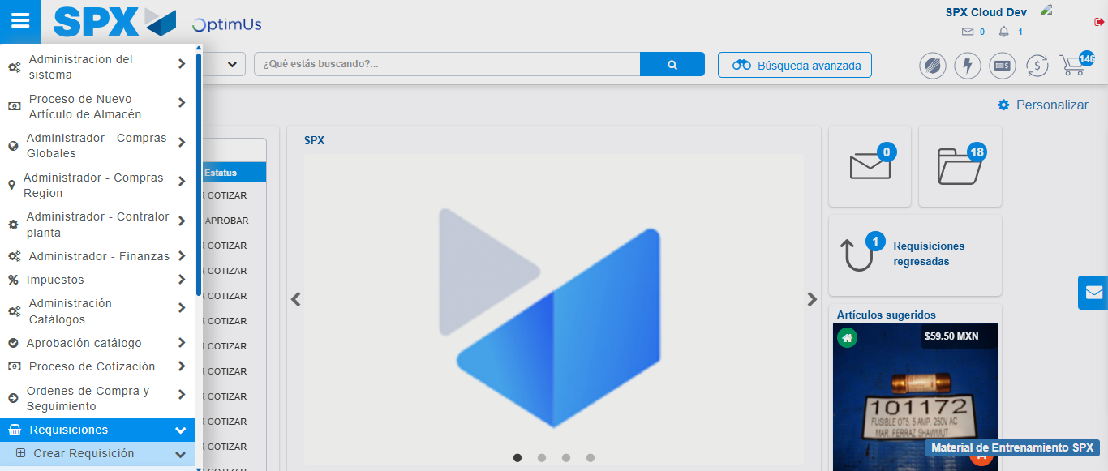Image file-name: QC_Testing-tc001_SPX_Dev5_Crear_Nueva_Linea_Requisicion_Spot_Tipo_Cobro_CC-nov. 28 2025, 09 31 57 a. m.

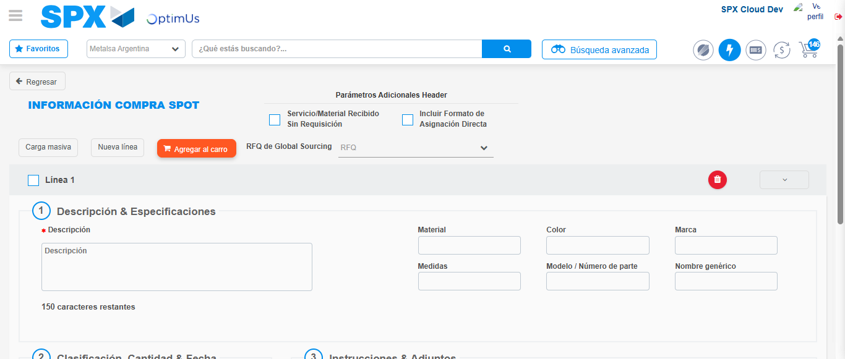Image file-name: QC_Testing-tc001_SPX_Dev5_Crear_Nueva_Linea_Requisicion_Spot_Tipo_Cobro_CC-nov. 28 2025, 09 32 00 a. m.

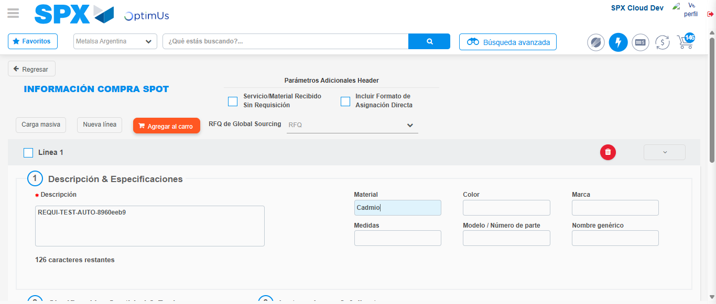Image file-name: QC_Testing-tc001_SPX_Dev5_Crear_Nueva_Linea_Requisicion_Spot_Tipo_Cobro_CC-nov. 28 2025, 09 32 01 a. m.

Step 3 - Data Capture Spot Buy Requisition: Data captured correctly
Image file-name: QC_Testing-tc001_SPX_Dev5_Crear_Nueva_Linea_Requisicion_Spot_Tipo_Cobro_CC-nov. 28 2025, 09 32 01 a. m.

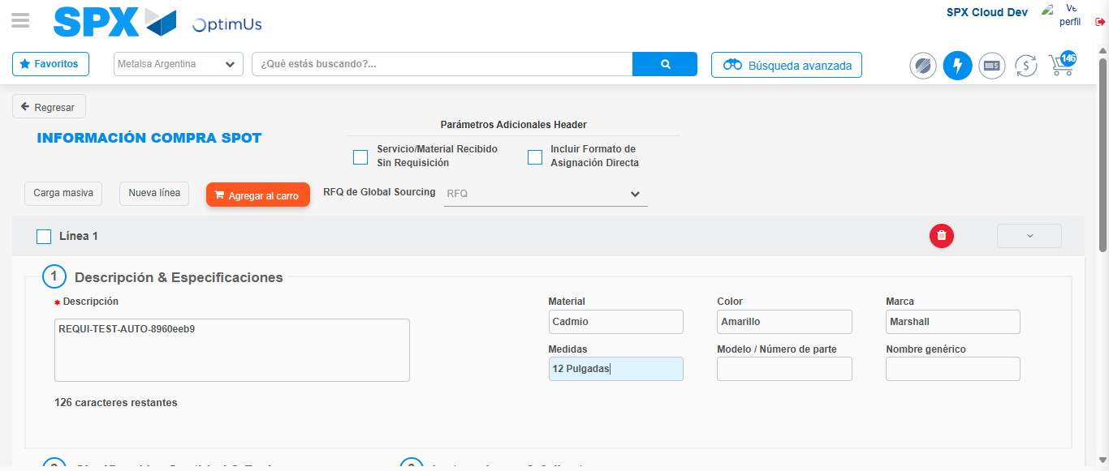Image file-name: QC_Testing-tc001_SPX_Dev5_Crear_Nueva_Linea_Requisicion_Spot_Tipo_Cobro_CC-nov. 28 2025, 09 32 02 a. m.

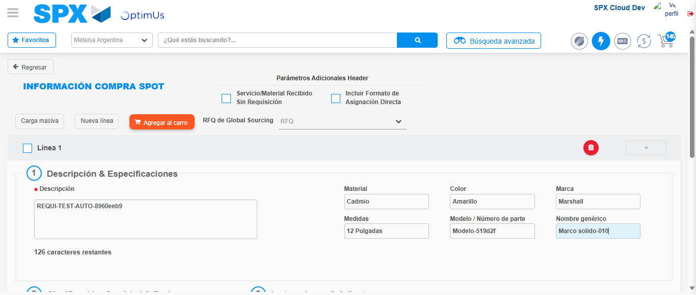Image file-name: QC_Testing-tc001_SPX_Dev5_Crear_Nueva_Linea_Requisicion_Spot_Tipo_Cobro_CC-nov. 28 2025, 09 32 03 a. m.

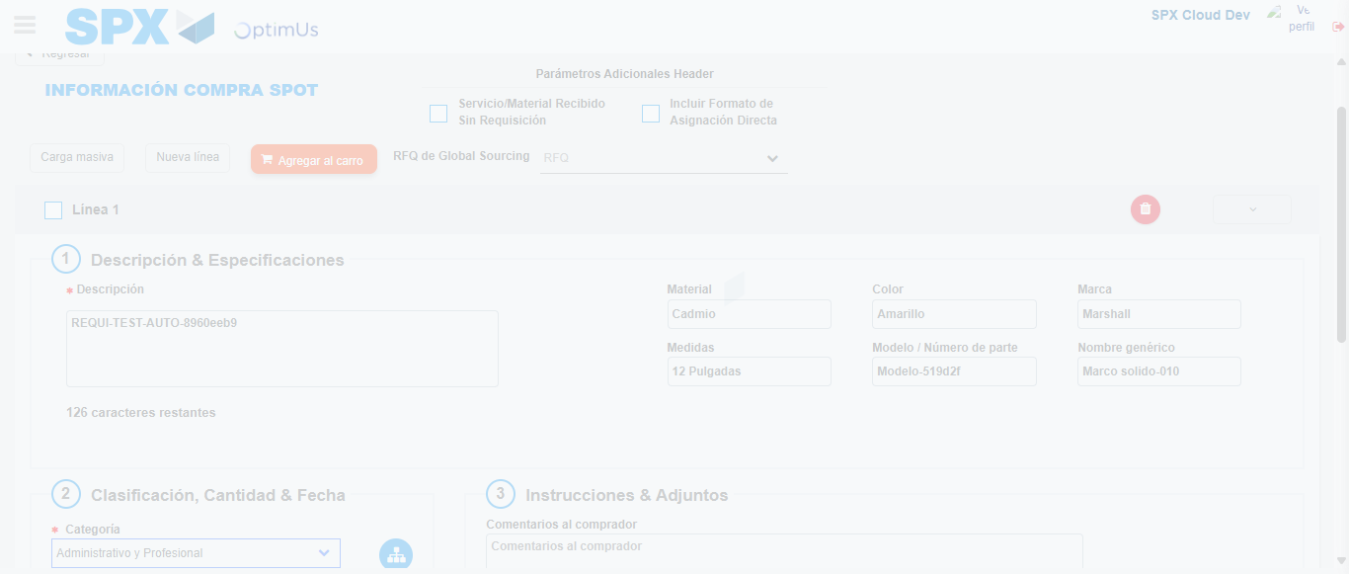Image file-name: QC_Testing-tc001_SPX_Dev5_Crear_Nueva_Linea_Requisicion_Spot_Tipo_Cobro_CC-nov. 28 2025, 09 32 04 a. m.

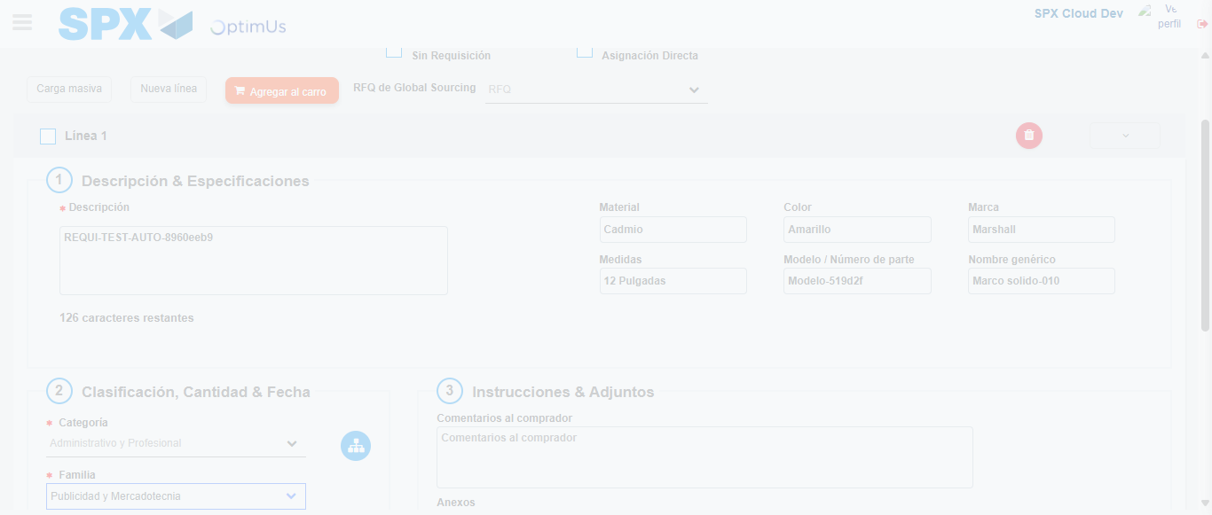Image file-name: QC_Testing-tc001_SPX_Dev5_Crear_Nueva_Linea_Requisicion_Spot_Tipo_Cobro_CC-nov. 28 2025, 09 32 05 a. m.

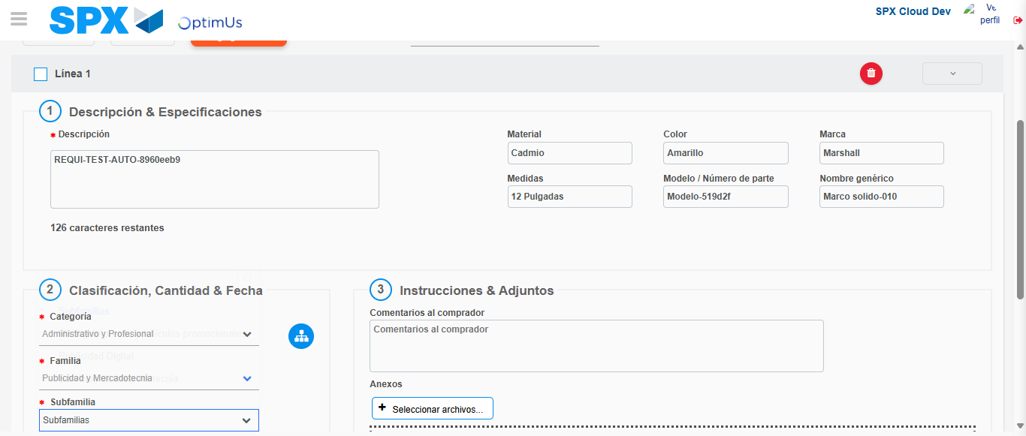Image file-name: QC_Testing-tc001_SPX_Dev5_Crear_Nueva_Linea_Requisicion_Spot_Tipo_Cobro_CC-nov. 28 2025, 09 32 06 a. m.

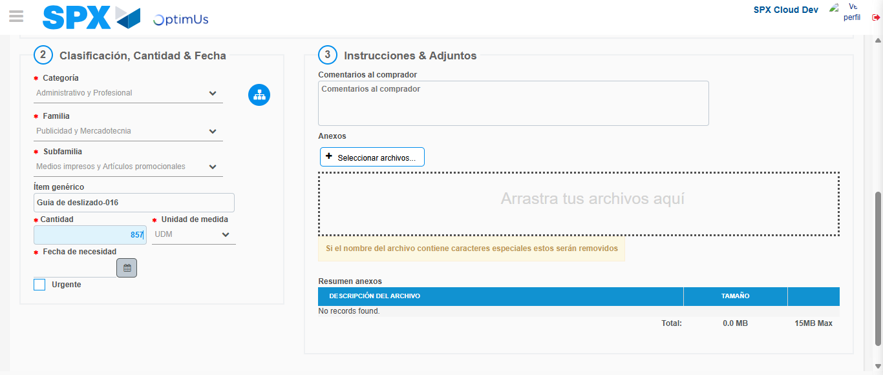Image file-name: QC_Testing-tc001_SPX_Dev5_Crear_Nueva_Linea_Requisicion_Spot_Tipo_Cobro_CC-nov. 28 2025, 09 32 07 a. m.

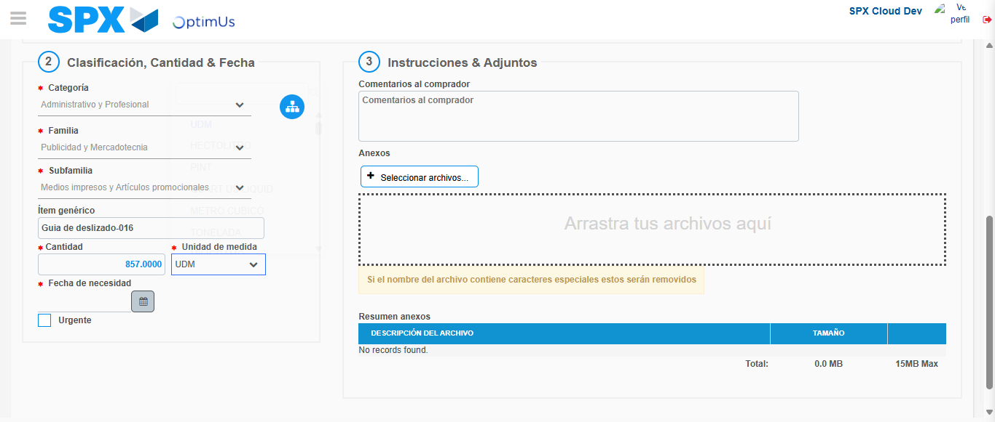Image file-name: QC_Testing-tc001_SPX_Dev5_Crear_Nueva_Linea_Requisicion_Spot_Tipo_Cobro_CC-nov. 28 2025, 09 32 08 a. m.

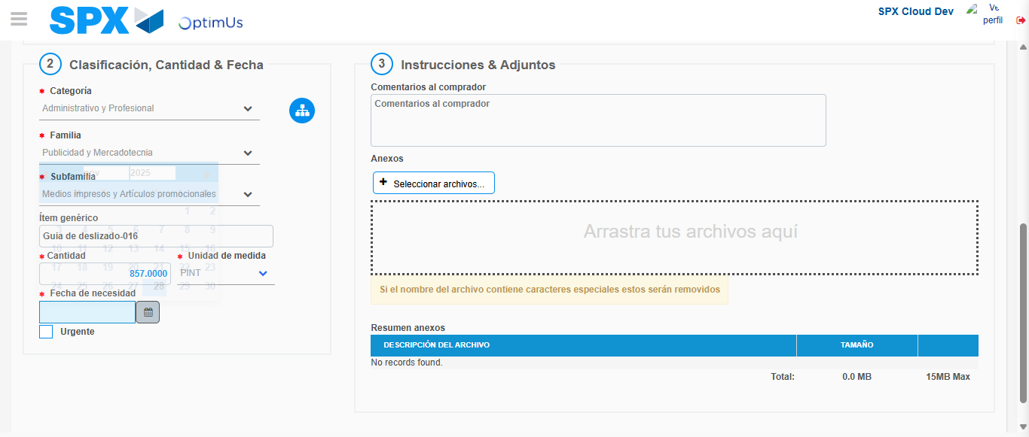Image file-name: QC_Testing-tc001_SPX_Dev5_Crear_Nueva_Linea_Requisicion_Spot_Tipo_Cobro_CC-nov. 28 2025, 09 32 09 a. m.

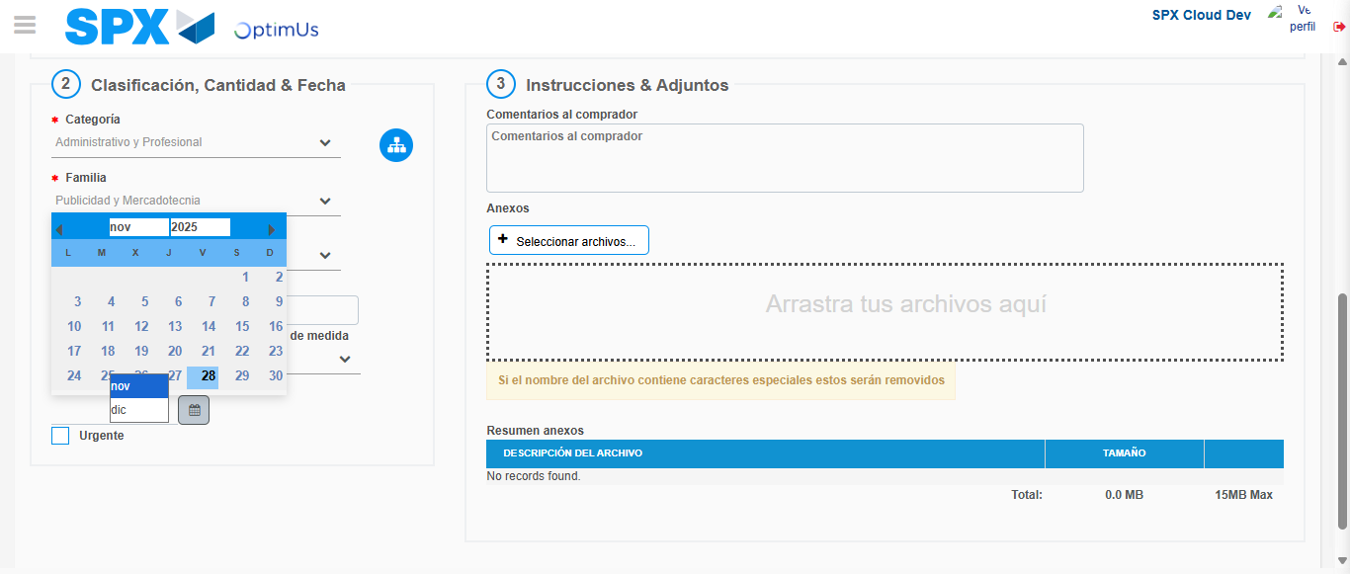Image file-name: QC_Testing-tc001_SPX_Dev5_Crear_Nueva_Linea_Requisicion_Spot_Tipo_Cobro_CC-nov. 28 2025, 09 32 10 a. m.

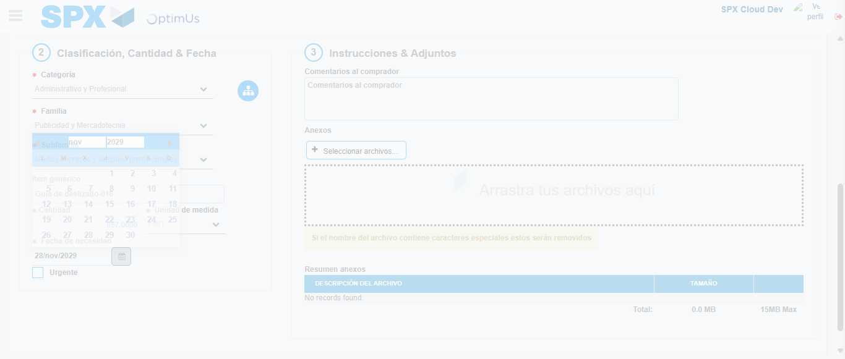Image file-name: QC_Testing-tc001_SPX_Dev5_Crear_Nueva_Linea_Requisicion_Spot_Tipo_Cobro_CC-nov. 28 2025, 09 32 11 a. m.

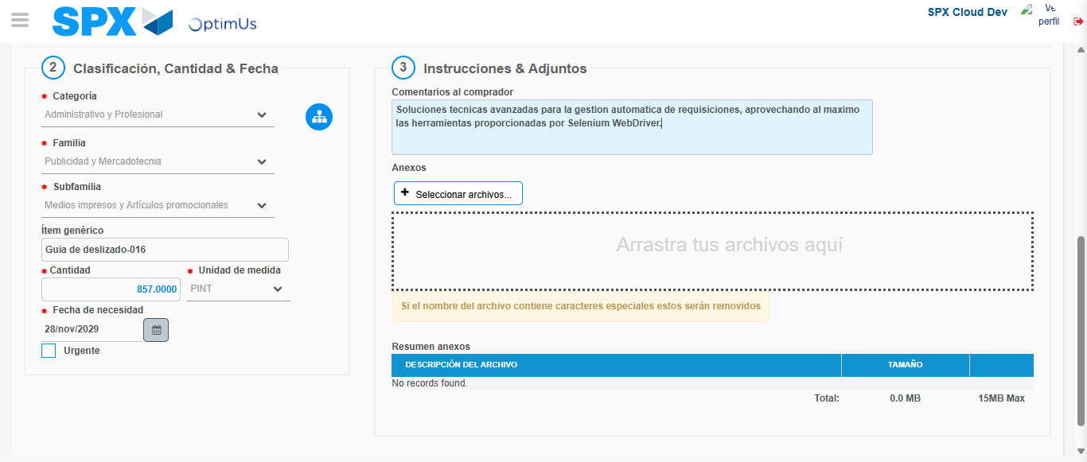Image file-name: QC_Testing-tc001_SPX_Dev5_Crear_Nueva_Linea_Requisicion_Spot_Tipo_Cobro_CC-nov. 28 2025, 09 32 12 a. m.

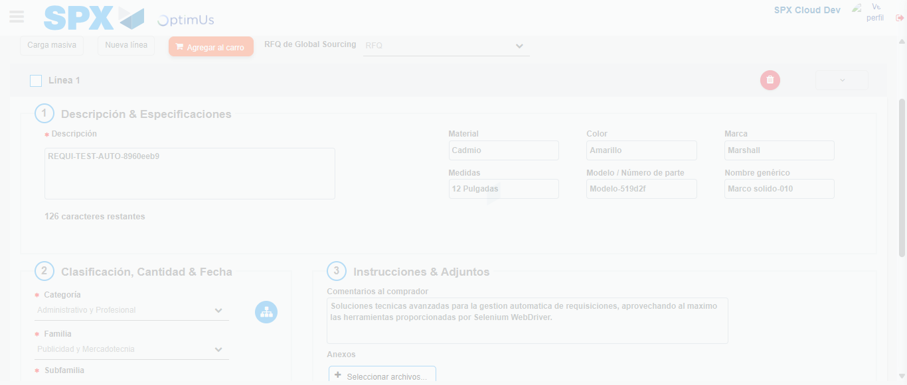Image file-name: QC_Testing-tc001_SPX_Dev5_Crear_Nueva_Linea_Requisicion_Spot_Tipo_Cobro_CC-nov. 28 2025, 09 32 13 a. m.

Step 4 - Add new line and data capture second line: Line add correctly
Image file-name: QC_Testing-tc001_SPX_Dev5_Crear_Nueva_Linea_Requisicion_Spot_Tipo_Cobro_CC-nov. 28 2025, 09 32 01 a. m.

Image file-name: QC_Testing-tc001_SPX_Dev5_Crear_Nueva_Linea_Requisicion_Spot_Tipo_Cobro_CC-nov. 28 2025, 09 32 02 a. m.

Image file-name: QC_Testing-tc001_SPX_Dev5_Crear_Nueva_Linea_Requisicion_Spot_Tipo_Cobro_CC-nov. 28 2025, 09 32 03 a. m.

Image file-name: QC_Testing-tc001_SPX_Dev5_Crear_Nueva_Linea_Requisicion_Spot_Tipo_Cobro_CC-nov. 28 2025, 09 32 04 a. m.

Image file-name: QC_Testing-tc001_SPX_Dev5_Crear_Nueva_Linea_Requisicion_Spot_Tipo_Cobro_CC-nov. 28 2025, 09 32 05 a. m.

Image file-name: QC_Testing-tc001_SPX_Dev5_Crear_Nueva_Linea_Requisicion_Spot_Tipo_Cobro_CC-nov. 28 2025, 09 32 06 a. m.

Image file-name: QC_Testing-tc001_SPX_Dev5_Crear_Nueva_Linea_Requisicion_Spot_Tipo_Cobro_CC-nov. 28 2025, 09 32 07 a. m.

Image file-name: QC_Testing-tc001_SPX_Dev5_Crear_Nueva_Linea_Requisicion_Spot_Tipo_Cobro_CC-nov. 28 2025, 09 32 08 a. m.

Image file-name: QC_Testing-tc001_SPX_Dev5_Crear_Nueva_Linea_Requisicion_Spot_Tipo_Cobro_CC-nov. 28 2025, 09 32 09 a. m.

Image file-name: QC_Testing-tc001_SPX_Dev5_Crear_Nueva_Linea_Requisicion_Spot_Tipo_Cobro_CC-nov. 28 2025, 09 32 10 a. m.

Image file-name: QC_Testing-tc001_SPX_Dev5_Crear_Nueva_Linea_Requisicion_Spot_Tipo_Cobro_CC-nov. 28 2025, 09 32 11 a. m.

Image file-name: QC_Testing-tc001_SPX_Dev5_Crear_Nueva_Linea_Requisicion_Spot_Tipo_Cobro_CC-nov. 28 2025, 09 32 12 a. m.

Image file-name: QC_Testing-tc001_SPX_Dev5_Crear_Nueva_Linea_Requisicion_Spot_Tipo_Cobro_CC-nov. 28 2025, 09 32 13 a. m.

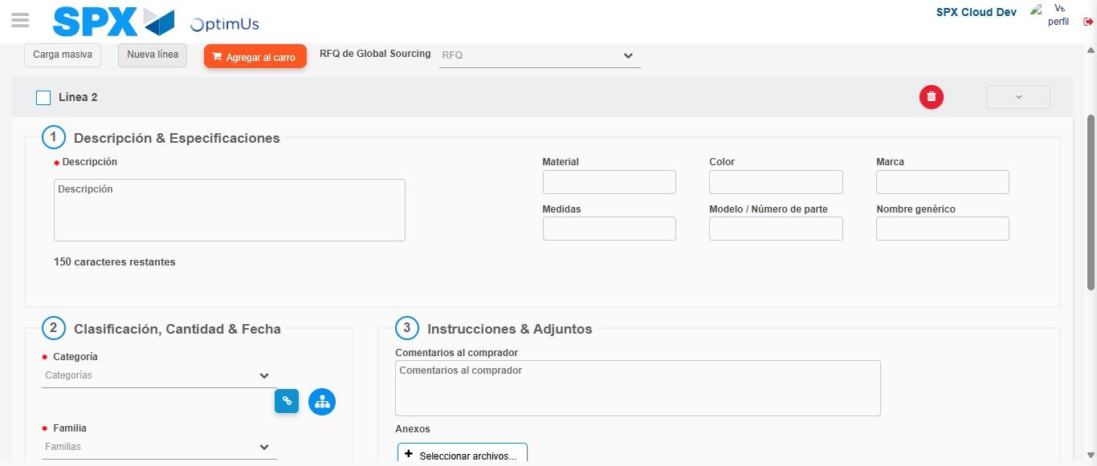Image file-name: QC_Testing-tc001_SPX_Dev5_Crear_Nueva_Linea_Requisicion_Spot_Tipo_Cobro_CC-nov. 28 2025, 09 32 16 a. m.

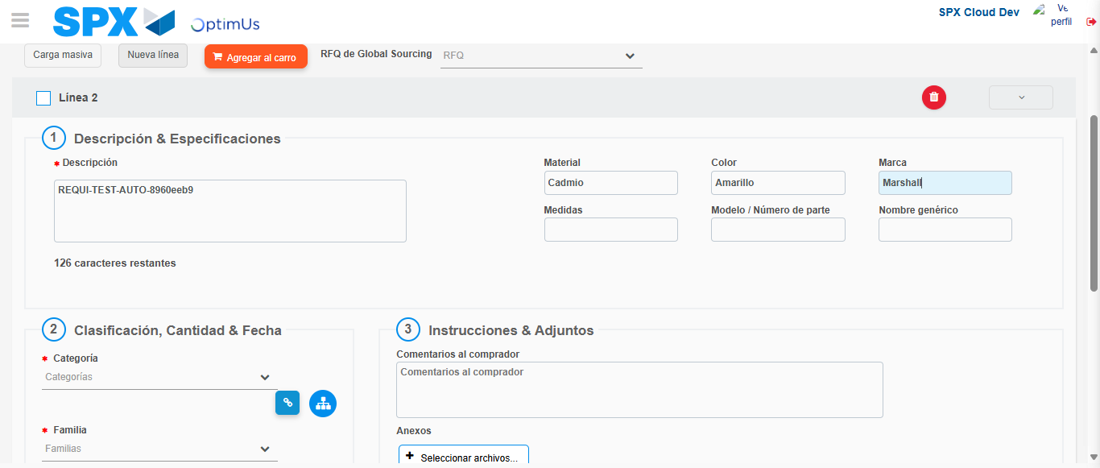Image file-name: QC_Testing-tc001_SPX_Dev5_Crear_Nueva_Linea_Requisicion_Spot_Tipo_Cobro_CC-nov. 28 2025, 09 32 17 a. m.

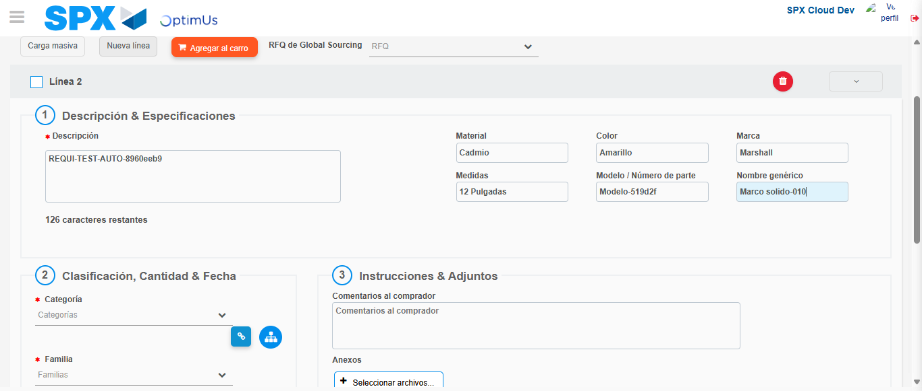Image file-name: QC_Testing-tc001_SPX_Dev5_Crear_Nueva_Linea_Requisicion_Spot_Tipo_Cobro_CC-nov. 28 2025, 09 32 18 a. m.

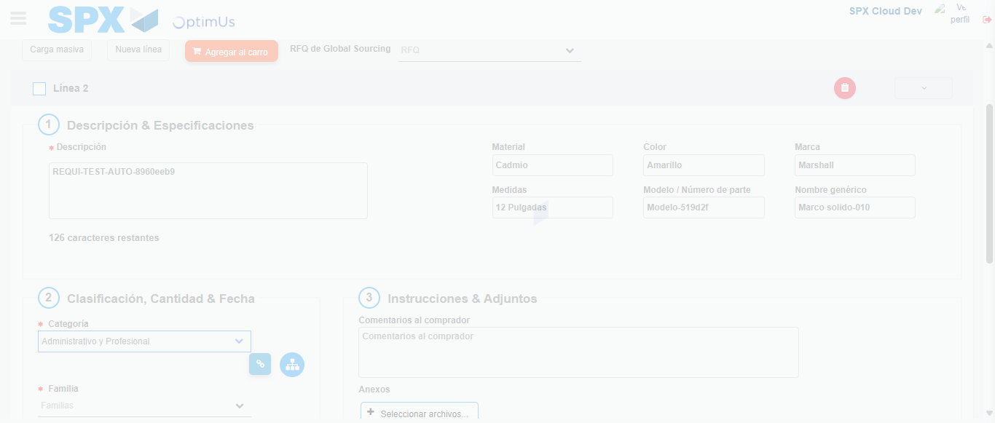Image file-name: QC_Testing-tc001_SPX_Dev5_Crear_Nueva_Linea_Requisicion_Spot_Tipo_Cobro_CC-nov. 28 2025, 09 32 19 a. m.

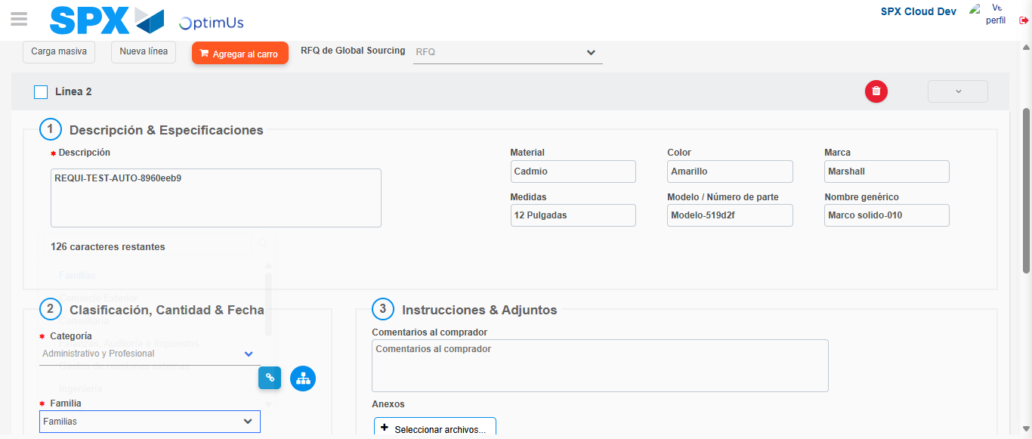Image file-name: QC_Testing-tc001_SPX_Dev5_Crear_Nueva_Linea_Requisicion_Spot_Tipo_Cobro_CC-nov. 28 2025, 09 32 20 a. m.

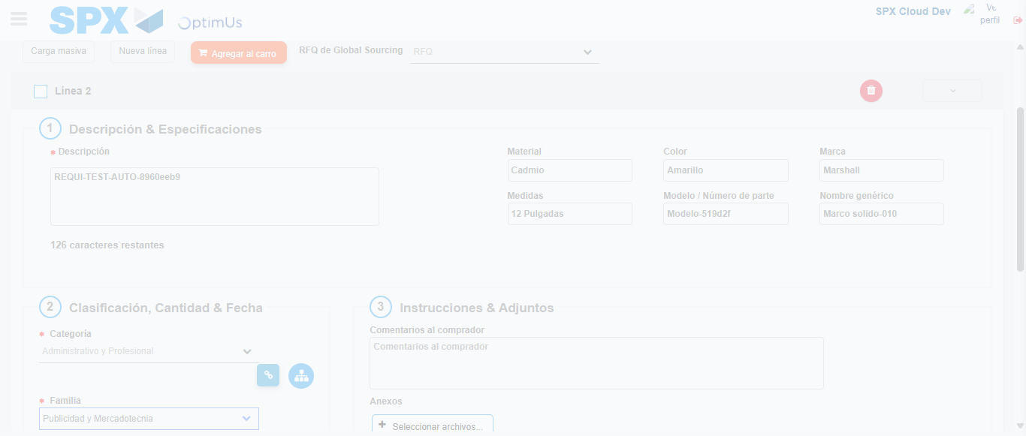Image file-name: QC_Testing-tc001_SPX_Dev5_Crear_Nueva_Linea_Requisicion_Spot_Tipo_Cobro_CC-nov. 28 2025, 09 32 21 a. m.

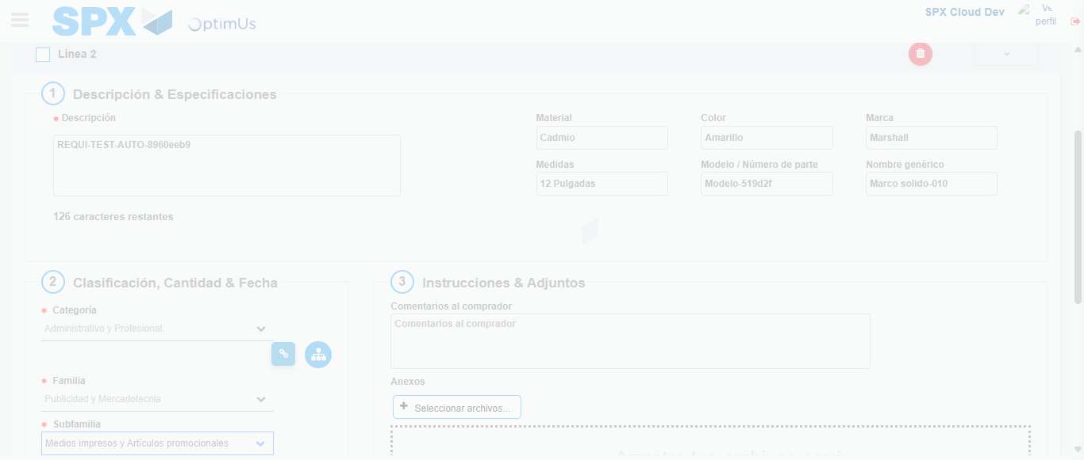Image file-name: QC_Testing-tc001_SPX_Dev5_Crear_Nueva_Linea_Requisicion_Spot_Tipo_Cobro_CC-nov. 28 2025, 09 32 24 a. m.

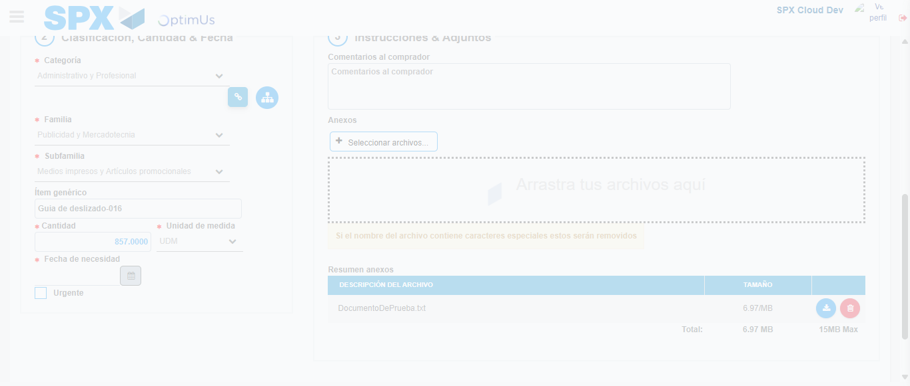Image file-name: QC_Testing-tc001_SPX_Dev5_Crear_Nueva_Linea_Requisicion_Spot_Tipo_Cobro_CC-nov. 28 2025, 09 32 25 a. m.

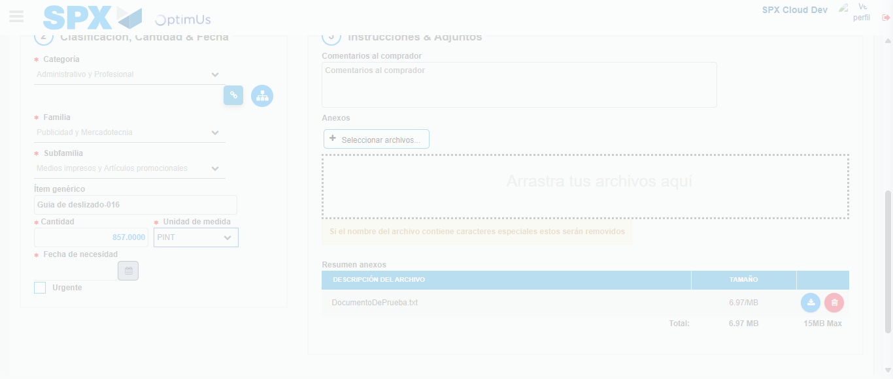Image file-name: QC_Testing-tc001_SPX_Dev5_Crear_Nueva_Linea_Requisicion_Spot_Tipo_Cobro_CC-nov. 28 2025, 09 32 26 a. m.

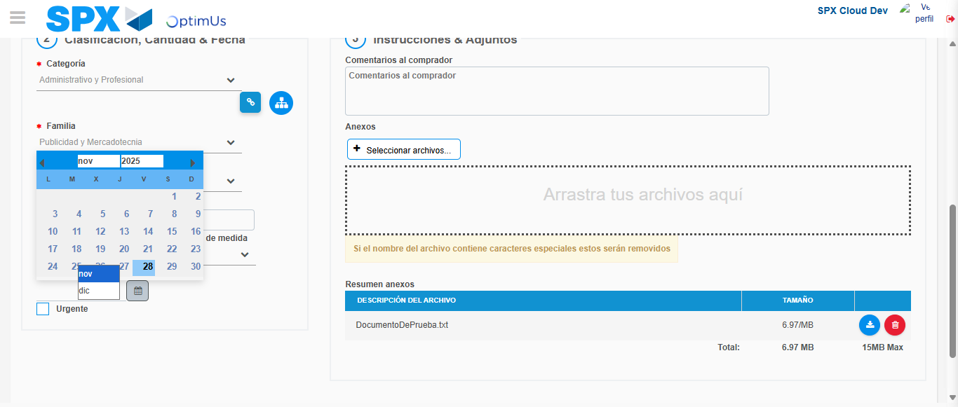Image file-name: QC_Testing-tc001_SPX_Dev5_Crear_Nueva_Linea_Requisicion_Spot_Tipo_Cobro_CC-nov. 28 2025, 09 32 27 a. m.

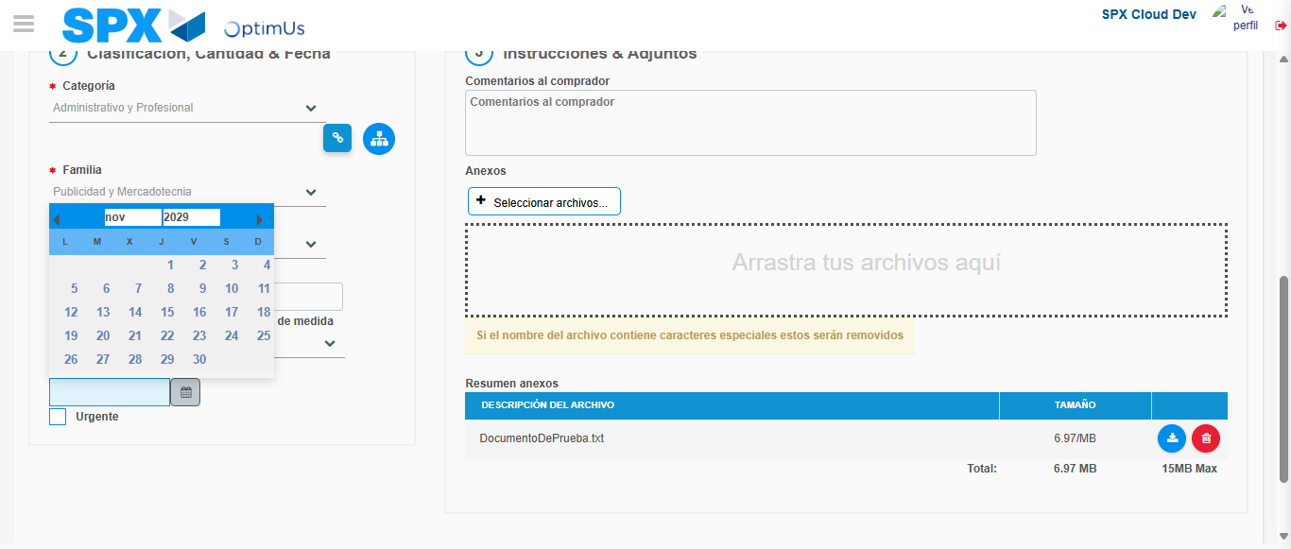Image file-name: QC_Testing-tc001_SPX_Dev5_Crear_Nueva_Linea_Requisicion_Spot_Tipo_Cobro_CC-nov. 28 2025, 09 32 28 a. m.

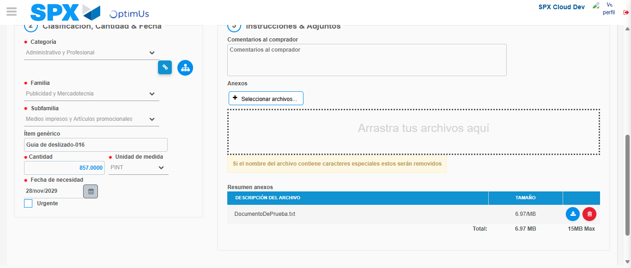Image file-name: QC_Testing-tc001_SPX_Dev5_Crear_Nueva_Linea_Requisicion_Spot_Tipo_Cobro_CC-nov. 28 2025, 09 32 29 a. m.

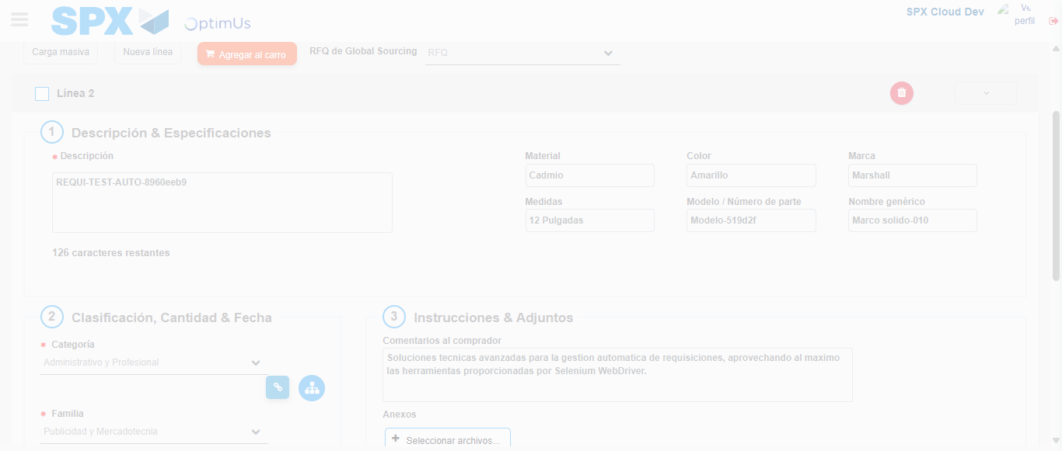Image file-name: QC_Testing-tc001_SPX_Dev5_Crear_Nueva_Linea_Requisicion_Spot_Tipo_Cobro_CC-nov. 28 2025, 09 32 30 a. m.

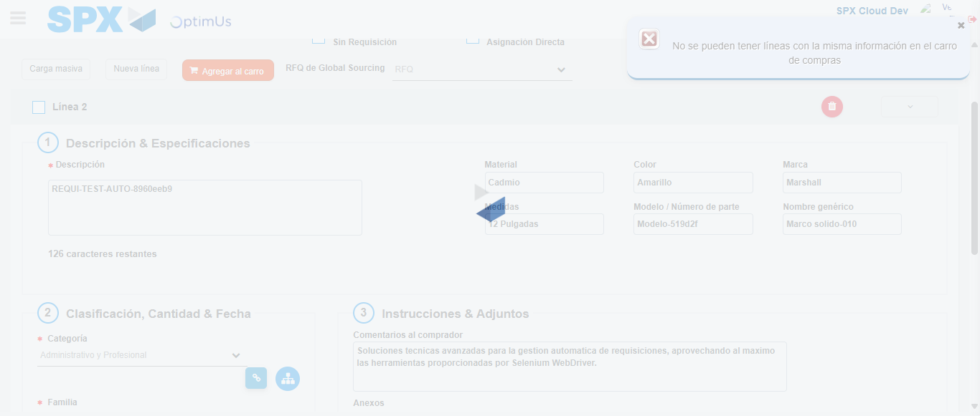Image file-name: QC_Testing-tc001_SPX_Dev5_Crear_Nueva_Linea_Requisicion_Spot_Tipo_Cobro_CC-nov. 28 2025, 09 32 31 a. m.

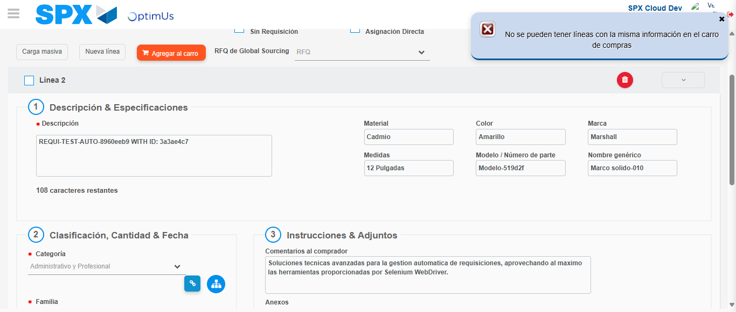Image file-name: QC_Testing-tc001_SPX_Dev5_Crear_Nueva_Linea_Requisicion_Spot_Tipo_Cobro_CC-nov. 28 2025, 09 32 32 a. m.

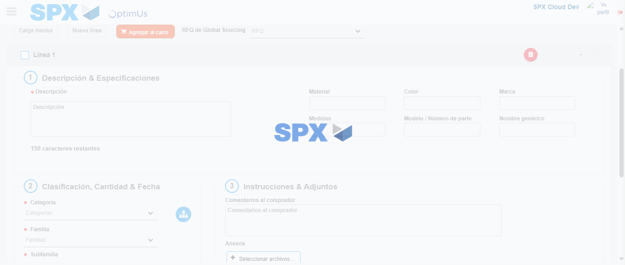Image file-name: QC_Testing-tc001_SPX_Dev5_Crear_Nueva_Linea_Requisicion_Spot_Tipo_Cobro_CC-nov. 28 2025, 09 32 35 a. m.

Step 5 - Select to Requisition: Requisition Correctly selected
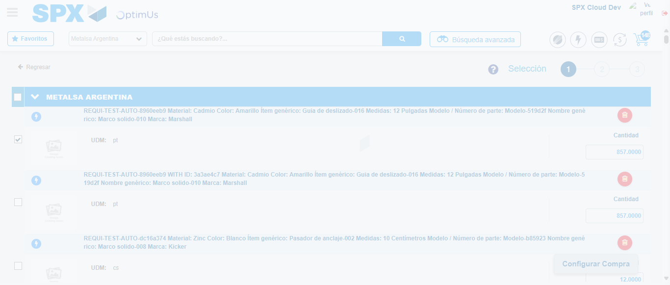Image file-name: QC_Testing-tc001_SPX_Dev5_Crear_Nueva_Linea_Requisicion_Spot_Tipo_Cobro_CC-nov. 28 2025, 09 32 44 a. m.

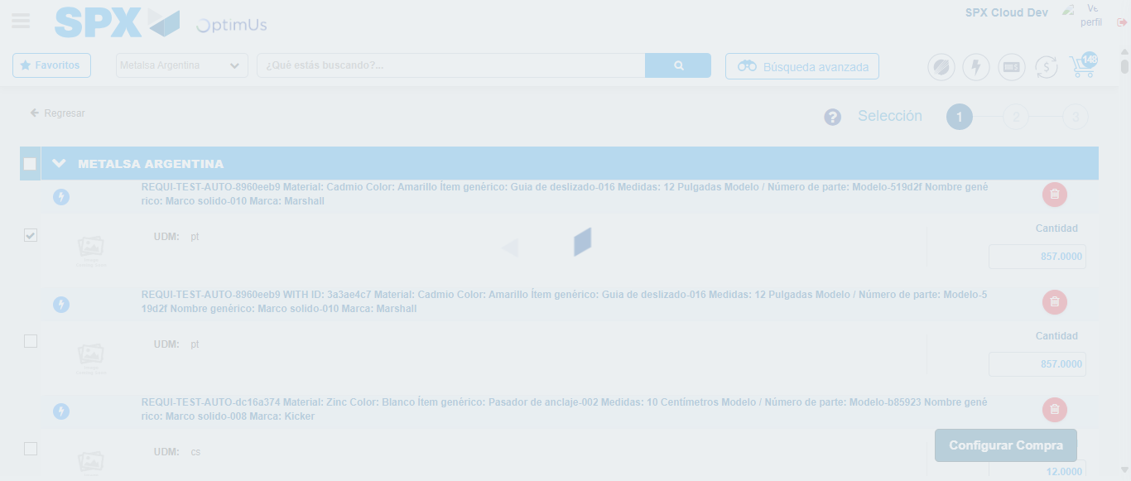Image file-name: QC_Testing-tc001_SPX_Dev5_Crear_Nueva_Linea_Requisicion_Spot_Tipo_Cobro_CC-nov. 28 2025, 09 32 49 a. m.

Step 6 - Select Type Account For Requisition: Type Account Correctly selected
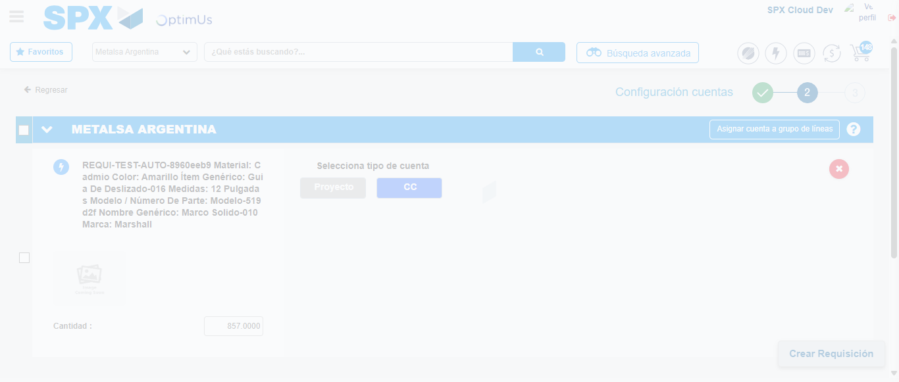Image file-name: QC_Testing-tc001_SPX_Dev5_Crear_Nueva_Linea_Requisicion_Spot_Tipo_Cobro_CC-nov. 28 2025, 09 32 54 a. m.

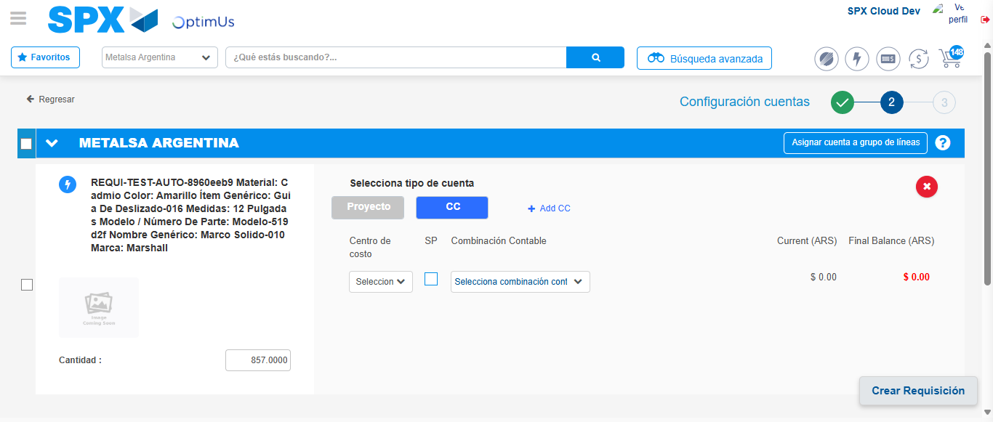Image file-name: QC_Testing-tc001_SPX_Dev5_Crear_Nueva_Linea_Requisicion_Spot_Tipo_Cobro_CC-nov. 28 2025, 09 32 57 a. m.

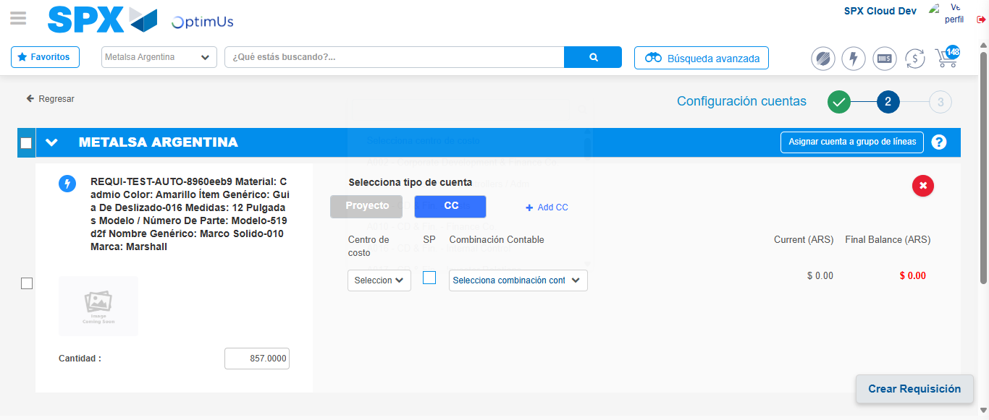Image file-name: QC_Testing-tc001_SPX_Dev5_Crear_Nueva_Linea_Requisicion_Spot_Tipo_Cobro_CC-nov. 28 2025, 09 33 00 a. m.

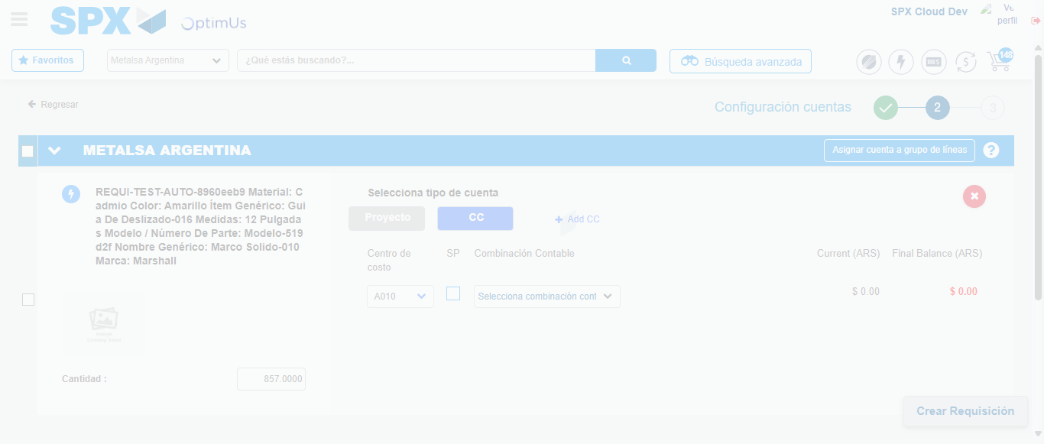Image file-name: QC_Testing-tc001_SPX_Dev5_Crear_Nueva_Linea_Requisicion_Spot_Tipo_Cobro_CC-nov. 28 2025, 09 33 01 a. m.

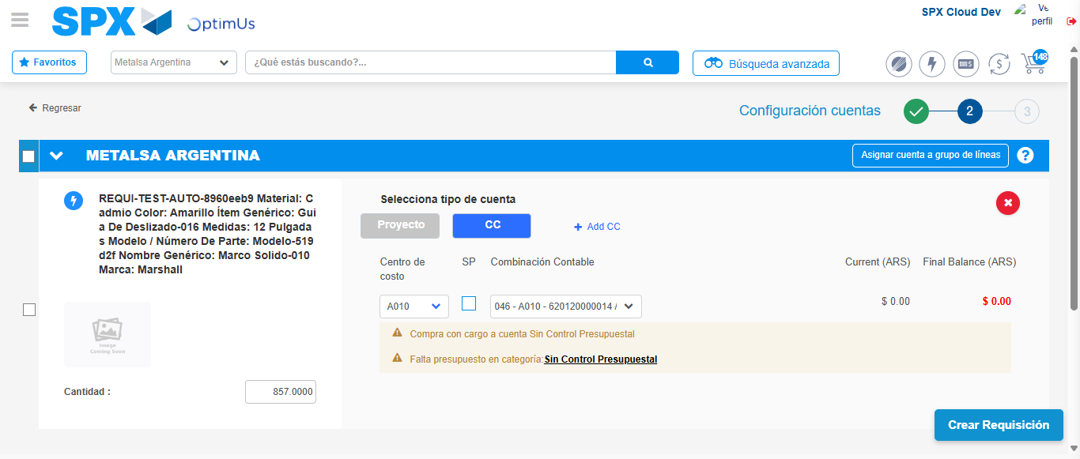Image file-name: QC_Testing-tc001_SPX_Dev5_Crear_Nueva_Linea_Requisicion_Spot_Tipo_Cobro_CC-nov. 28 2025, 09 33 04 a. m.

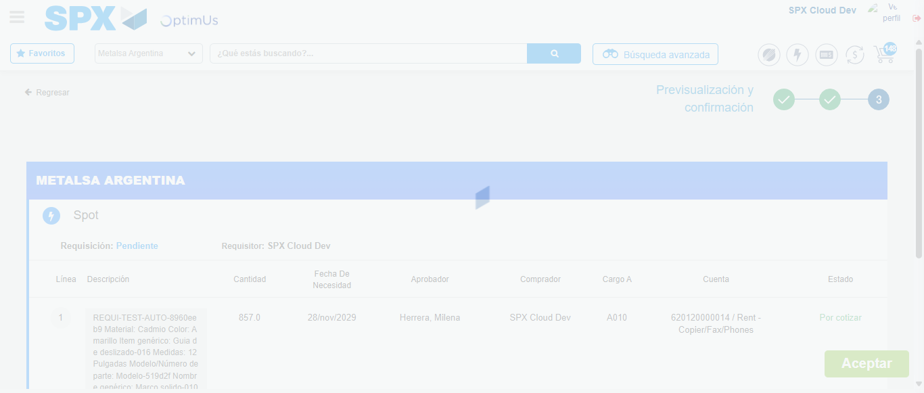Image file-name: QC_Testing-tc001_SPX_Dev5_Crear_Nueva_Linea_Requisicion_Spot_Tipo_Cobro_CC-nov. 28 2025, 09 33 05 a. m.

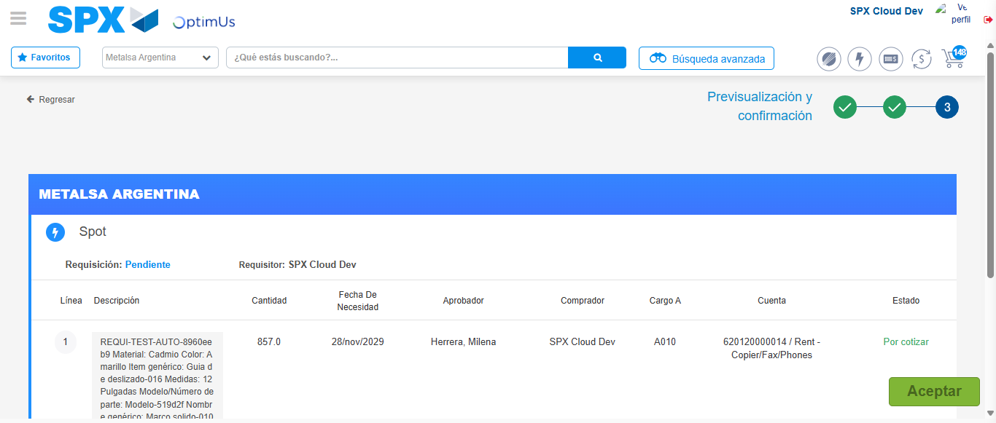Image file-name: QC_Testing-tc001_SPX_Dev5_Crear_Nueva_Linea_Requisicion_Spot_Tipo_Cobro_CC-nov. 28 2025, 09 33 08 a. m.

Step 7 - Accept to Requisition: Requisition Accepted
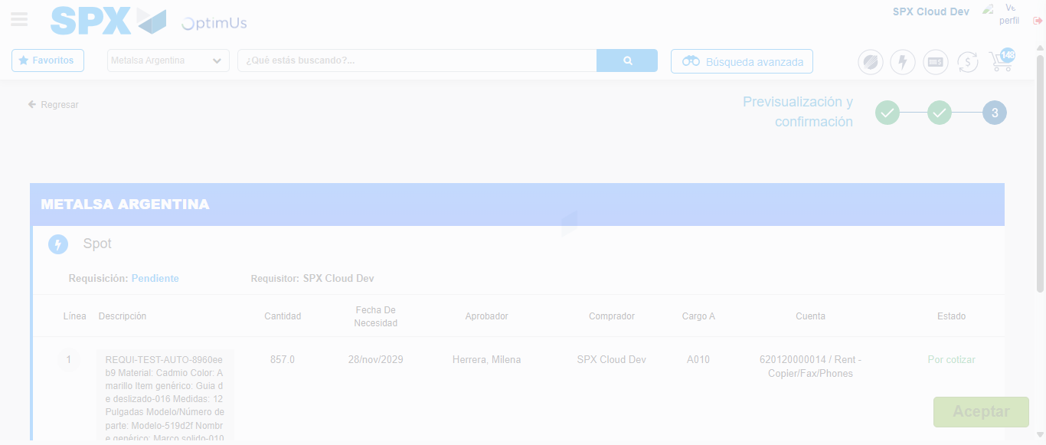Image file-name: QC_Testing-tc001_SPX_Dev5_Crear_Nueva_Linea_Requisicion_Spot_Tipo_Cobro_CC-nov. 28 2025, 09 33 09 a. m.

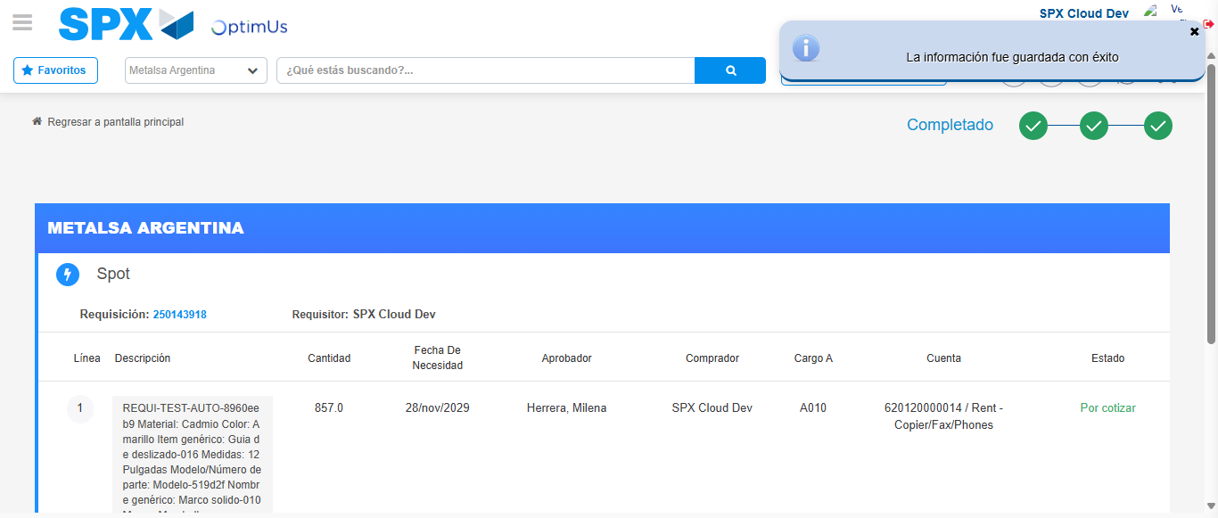Image file-name: QC_Testing-tc001_SPX_Dev5_Crear_Nueva_Linea_Requisicion_Spot_Tipo_Cobro_CC-nov. 28 2025, 09 33 12 a. m.

